**To Create a yaml file with suitable name**

**cd /etc/ansible**

**vi system_info.yml**

**TASK 1**  
---  
 - hosts: all  
   tasks:  
   - name: hostname  
     debug:  
       var=ansible_hostname  
  
[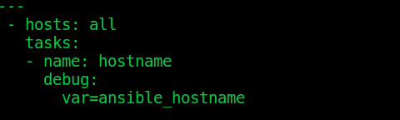](https://4.bp.blogspot.com/-jhTFdMkc0yc/XGZmBhlUz5I/AAAAAAAAEWA/E9GOEcTRooYG8whJbRPPrc_i9XQ0Fuo3ACEwYBhgL/s1600/Screenshot%2Bfrom%2B2019-02-15%2B12-38-04.png)  
  
You may check ansible first task by sava this ansible playbook yml file and execute / run using ansible-playbook command.  
  
**First we will check syntax error using --check-syntax flags**

**ansible-playbook  --check-syntax system_info.yml**

**To run / execute ansible playbook**

**ansible-playbook system_info.yml**

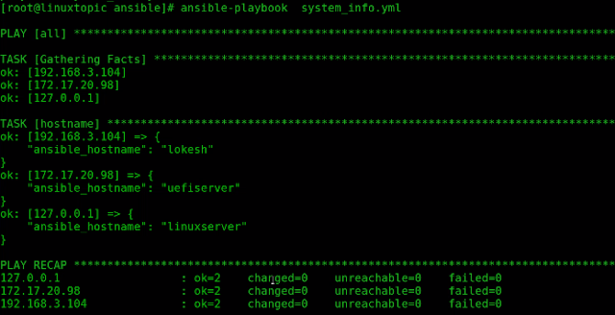  
**TASK - 2**  
  
**ansible tasks :  we will print system date and  timezone of hosts. we define ansible variable  and use debug module.**  
  
   - name: date and time  
     vars:  
      msg: |  
       Date: {{ ansible_date_time.date }}  
       Timezone: {{ ansible_date_time.tz }}  
     debug:  
      msg: "{{ msg.split('\n') }}"  
  
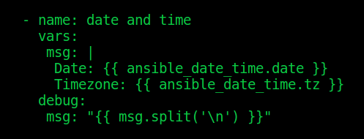  
**TASK 3**  
  
Ansible Tasks : we will print system network information. we define ansible variable like **ansible_interfaces** to print all Interface of system,  **ansible_all_ipv4_addresses** to Print all ipv4,  **ansible_default_ipv4** to Print default Gateway and **ansible_eth0** to Print eth0 MAC Address.

   - name: network info  
     vars:  
      msg: |  
       All Interface List: {{ ansible_interfaces }}  
       All IP: {{ ansible_all_ipv4_addresses }}  
       Gateway: {{ ansible_default_ipv4.gateway }}  
       Eth0 MAC: {{ ansible_eth0.macaddress }}  
     debug:  
      msg: "{{ msg.split('\n') }}"  
  
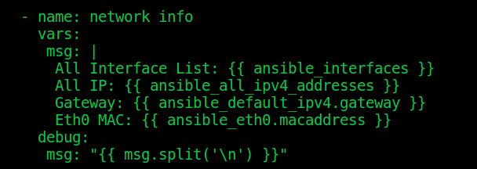 **TASK 4**  
  
Ansible Tasks:  we will print system OS and Kernel Information. we define ansible variable like **ansible_distribution** to print OS Distribution, **ansible_distribution_release** to print OS Release, **ansible_distribution_version** to Print OS Version, **ansible_kernel** to print Kernel Version and **ansible_architecture** to Print OS Architecture.  
  
   - name: OS and Kernel info  
     vars:  
      msg: |  
       Distribution: {{ ansible_distribution }}  
       Release: {{ ansible_distribution_release }}  
       Distribution Version: {{ ansible_distribution_version }}  
       Kernel: {{ ansible_kernel }}  
       Architecture: {{ ansible_architecture }}  
     debug:  
      msg: "{{ msg.split('\n') }}"  
  
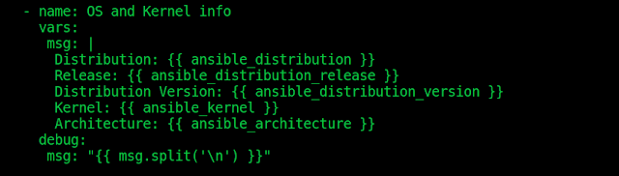  
  
**TASK 5**  
  
A the end of  ansible tasks we will print system Hardware Information. we define ansible variable like **ansible_processor** to print  CPU, **ansible_processor_core** to print CPU Core Information, **ansible_memtotal_mb** to print system RAM, and **ansible_memory_mb.swap.total** to print system SWAP Memory.  
  
   - name: HW info  
     vars:  
      msg: |  
       CPU: {{ ansible_processor }}  
       CPU Core: {{ ansible_processor_cores }}  
       RAM: {{ ansible_memtotal_mb }}  
       SWAP: {{ ansible_memory_mb.swap.total }}  
     debug:  
      msg: "{{ msg.split('\n') }}"  
  
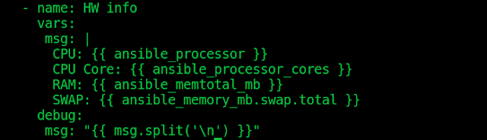  
**The Final ansible playbook look like :**

**cat system_info.yml**

---  
 - hosts: all  
   tasks:  
   - name: hostname  
     debug:  
       var=ansible_hostname  
  
   - name: date and time  
     vars:  
      msg: |  
       Date: {{ ansible_date_time.date }}  
       Timezone: {{ ansible_date_time.tz }}  
     debug:  
      msg: "{{ msg.split('\n') }}"  
  
   - name: network info  
     vars:  
      msg: |  
       All Interface List: {{ ansible_interfaces }}  
       All IP: {{ ansible_all_ipv4_addresses }}  
       Gateway: {{ ansible_default_ipv4.gateway }}  
       Eth0 MAC: {{ ansible_eth0.macaddress }}  
     debug:  
      msg: "{{ msg.split('\n') }}"  
  
   - name: OS and Kernel info  
     vars:  
      msg: |  
       Distribution: {{ ansible_distribution }}  
       Release: {{ ansible_distribution_release }}  
       Distribution Version: {{ ansible_distribution_version }}  
       Kernel: {{ ansible_kernel }}  
       Architecture: {{ ansible_architecture }}  
     debug:  
      msg: "{{ msg.split('\n') }}"  
  
   - name: HW info  
     vars:  
      msg: |  
       CPU: {{ ansible_processor }}  
       CPU Core: {{ ansible_processor_cores }}  
       RAM: {{ ansible_memtotal_mb }}  
       SWAP: {{ ansible_memory_mb.swap.total }}  
     debug:  
  
      msg: "{{ msg.split('\n') }}"  
 **To check the syntax of a playbook with the --syntax-check flag.**

**ansible-playbook --syntax-check system_info.yml**

  
**To run playbook on hosts of inventory**

**ansible-playbook  system_info.yml**

